**Project Name: Drug Distribution Management System**

**Project Member:**

**Vishwas Varma 230943120111**

**Roopali Jain 230943120066**

**Priyanka fegade 230943120059**

**Rushikesh Mandlik 230943120109**

**Abstract:**

The Drug Distribution Management System (DDMS) serves as a unified web-based platform where both pharmacists and distributors access a shared interface for efficient collaboration in the pharmaceutical supply chain.

Pharmacists initiate the order process by searching for and selecting medicines, adding them to the cart, and submitting requests. Simultaneously, distributors log in to the same platform to view incoming orders, allowing them to approve or cancel requests.

This seamless interaction facilitates a streamlined CRUD (Create, Read, Update, Delete) operation, with real-time updates displayed on both the pharmacist and distributor interfaces.

The system prioritizes simplicity, transparency, and effective communication, providing a cohesive interface to enhance the efficiency of drug distribution between pharmacists and distributors.

Top of Form

**Implementation Technologies:**

1. **Spring Framework:**

Spring Framework is a Java platform that provides comprehensive infrastructure support for developing Java applications. Spring handles the infrastructure so you can focus on your application.

Spring enables you to build applications from “plain old Java objects” (POJOs) and to apply enterprise services non-invasively to POJOs. This capability applies to the Java SE programming model and to full and partial Java EE.

**1.1      Features of Spring Framework:**

**1. Lightweight**

Spring is modular lightweight framework which allows you to selectively use any of its modules on the top of Spring Core.

**2. Inversion of Control (IOC)**

This is another top feature of Spring framework where application dependencies are satisfied by the framework itself. Framework creates the object in runtime and satisfies application dependencies.

**3. Aspect Oriented Programming (AOP)**

Aspect Oriented Programming (AOP) is very popular in programming world and in Spring it is well implemented. Developer can use Aspect Oriented Programming (AOP feature of Spring to develop application in which business logic is separated from system services.

**4. Container**

Spring provides their own container for managing the bean lifecycle.

**5. MVC Framework**

Spring MVC Framework is used for developing MVC based web applications.

**6. Transaction Management**

Spring framework provides generic Transaction Management layer which can be used with or without J2EE(JEE) environment.

**7. JDBC Exception Handling**

Spring provides their own abstraction of JDBC exception which further simplifies the exception handling in program.

**1.2 Advantages of Spring Framework:**

**1. Solving difficulties of Enterprise application development**

Spring is solving the difficulties of development of complex applications, it provides Spring Core, Spring IoC and Spring AOP for integrating various components of business applications.

**2. Support Enterprise application development through POJOs**

Spring supports development of Enterprise application development using the POJO classes which removes the need of importing heavy Enterprise container during development. This makes application testing much easier.

**3. Easy integration other frameworks**

Spring designed to be used with all other frameworks of Java, you can use ORM, Struts, Hibernate and other frameworks of Java together. Spring framework do not impose any restriction on the frameworks to be used together.

**4. Application Testing**

Spring Container can be used to develop and run test cases outside enterprise container which makes testing much easier.

**5. Modularity**

Spring framework is modular framework and it comes with many modules such as Spring MVC, Spring ORM, Spring JDBC, Spring Transactions etc. which can used as per application requirement in modular fashion.

**6. Spring Transaction Management**

Spring Transaction Management interface is very flexible it can configure to use local transactions in small application which can be scaled to JTA for global transactions.

1. **The JDBC Template**

The central class of the Spring JDBC abstraction framework is the **JdbcTemplate** class that includes the most common logic in using the JDBC API to access data, such as handling the creation of connection, statement creation, statement execution, and release of resource. The**Jdbc-Template**class can be found in the **org.springframework.jdbc.core**package.

The **JdbcTemplate** class instances are thread-safe once configured. A single **JdbcTemplate** can be configured and injected into multiple DAOs.

We can use the **JdbcTemplate** to execute the different types of SQL statements. **Data Manipulation Language** (**DML**) is used for inserting, retrieving, updating, and deleting the data in the database such as **SELECT**, **INSERT**, or **UPDATE** statements

**2.1** **MySQL**

MySQL, the most popular Open Source SQL database management system, is developed, distributed, and supported by Oracle Corporation.

**Features of MySQL:**

* **MySQL is a database management system.**

A database is a structured collection of data. It may be anything from a simple shopping list to a picture gallery or the vast amounts of information in a corporate network. To add, access, and process data stored in a computer database, you need a database management system such as MySQL Server. Since computers are very good at handling large amounts of data, database management systems play a central role in computing, as standalone utilities, or as parts of other applications.

* **MySQL databases are relational.**

A relational database stores data in separate tables rather than putting all the data in one big storeroom. The database structures are organized into physical files optimized for speed. The logical model, with objects such as databases, tables, views, rows, and columns, offers a flexible programming environment.

* **MySQL software is Open Source.**

Open Source means that it is possible for anyone to use and modify the software. Anybody can download the MySQL software from the Internet and use it without paying anything.

* **The MySQL Database Server is very fast, reliable, scalable, and easy to use.**

MySQL Server was originally developed to handle large databases much faster than existing solutions and has been successfully used in highly demanding production environments for several years. Although under constant development, MySQL Server today offers a rich and useful set of functions. Its connectivity, speed, and security make MySQL Server highly suited for accessing databases on the Internet.

* **MySQL Server works in client/server or embedded systems.**

The MySQL Database Software is a client/server system that consists of a multithreaded SQL server that supports different back ends, several different client programs and libraries, administrative tools, and a wide range of application programming interfaces (APIs).

1. **Hardware and Software Requirements (Minimum):**

**Hardware:**

1. Intel i3 processor 3rd generation or later / AMD Ryzen 200 2nd generation or later

2. 2 GB ddr3 ram.

3. Windows 7 Home edition or later.

4. 200 GB Sata HDD Space

5. Data Connection 200 kbps

**Software:**

1. Eclipse 4.7 Oxygen
2. MySQL 5.7 with Workbench 8.0
3. Google Chrome version 79.0
4. Apache Tomcat Server 8.5
5. Maven Dependencies

**4.Diagram**

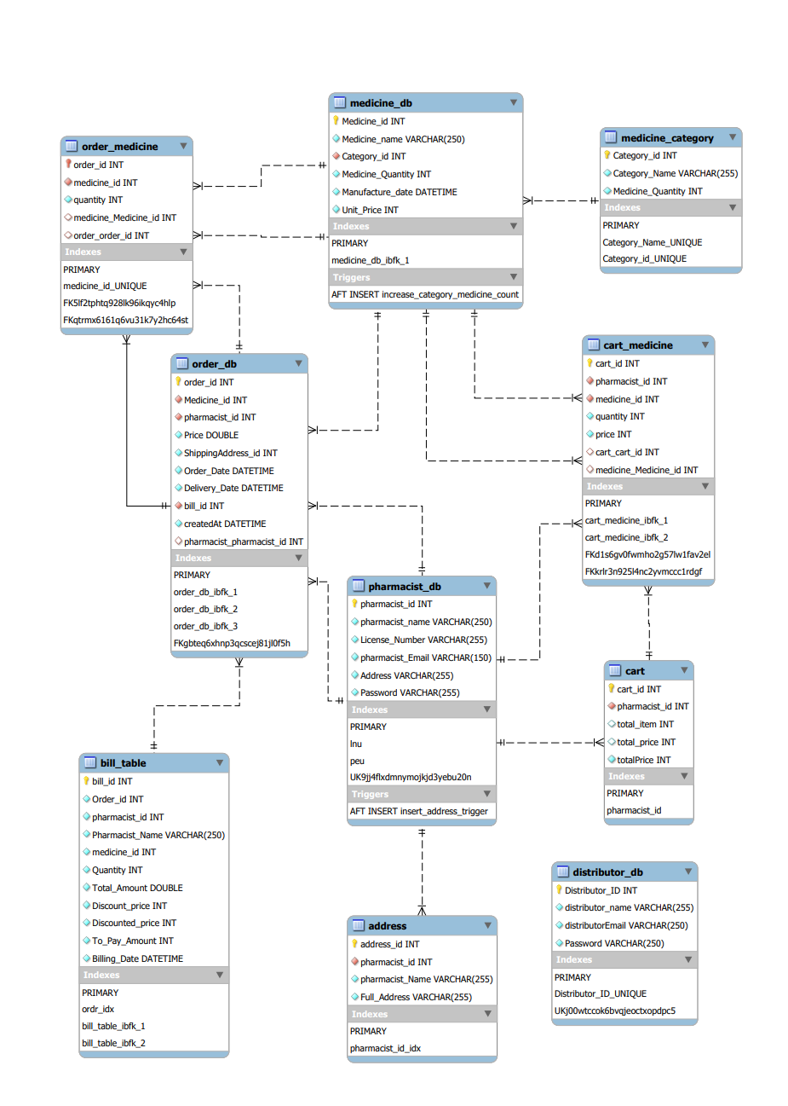

**5.End-to-End Flow of Drug Distribution Management System (DDMS):**

1. **User Authentication:**
   * Pharmacists and distributors log in using secure credentials.
2. **Pharmacist Actions:**
   * Pharmacists search for medicines and add them to the cart.
   * The pharmacist initiates the order, triggering a request to distributors.
3. **Distributor Actions:**
   * Distributors log in and view incoming orders in a centralized dashboard.
   * Distributors review the order details and decide to approve or cancel the request.
4. **Order Approval:**
   * If approved, the distributor confirms the order, marking it for further processing.
5. **Real-Time Status Updates:**
   * Pharmacists receive real-time updates on the status of their orders, indicating whether the distributor approved or cancelled the request.
6. **Bounced Order Management (Future Enhancement):**
   * In case of order rejection, a bounced order is generated.
   * Distributors can manage bounced orders, providing a reason for rejection.
7. **Draft Order Management (Future Enhancement):**
   * Pharmacists can save draft orders for future submission.
   * Distributors can review and process draft orders at a later time.
8. **Financial Management (Future Enhancement):**
   * Pharmacists initiate the bill payment process for approved orders.
   * Distributors process bill payments, completing the financial transaction.
9. **User Account Management:**
   * Both pharmacists and distributors can manage their account details, including updating credentials and personal information.
10. **System Performance:**
    * The DDMS system ensures performance scalability, handling a efficient concurrent users seamlessly.
11. **Security Measures:**
    * User data is encrypted during transmission, ensuring the confidentiality and integrity of sensitive information.
12. **User-Friendly Interface:**
    * The DDMS interface is designed to be intuitive, promoting ease of use for both pharmacists and distributors.
13. **Compatibility:**
    * The system is compatible with modern web browsers, ensuring optimal performance and accessibility.

The end-to-end flow of the Drug Distribution Management System encompasses user authentication, order initiation by pharmacists, order processing by distributors, real-time status updates, and future enhancements for managing bounced orders, draft orders, and financial transactions. The system prioritizes security, scalability, and user-friendliness to create a seamless and efficient pharmaceutical supply chain management platform

**Thank You!**